**Bài thực hành 2**

**Quản trị mạng**

**Tên:** Hồ Chí Nguyên

**MSSV:** 2251050048

Câu 1:

Câu 2:

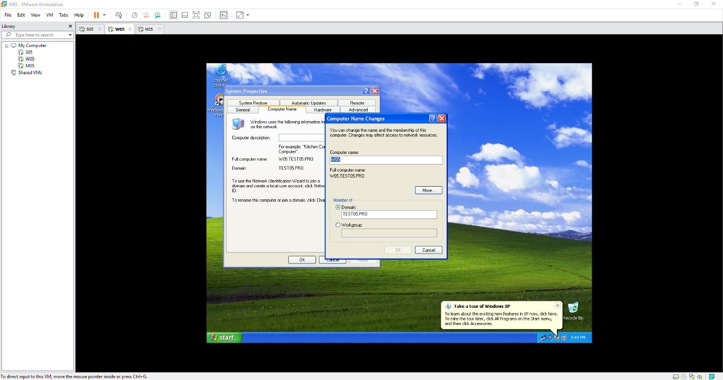

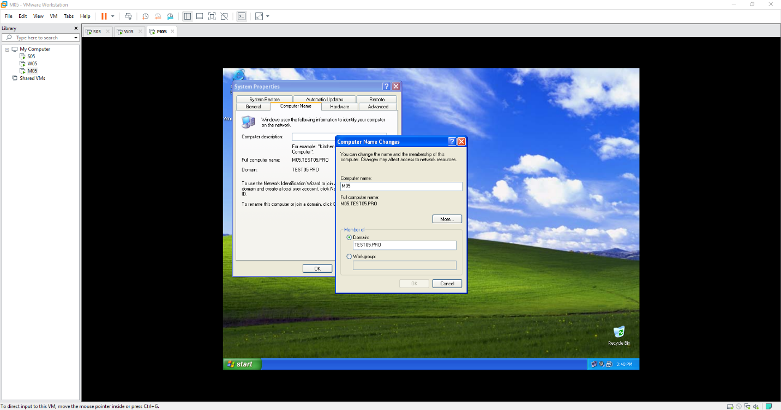

Câu 3:

Câu 4:

